Faculty of Computer Systems & Software Engineering

Universiti Malaysia Pahang



**BCS2303 Web Scripting**

**Semester 1 2016/2017**

Lab Section : 01B

Lecturer : Dr. Liew Siau Chuin

**HOT 1**

|  |  |
| --- | --- |
| **NAME** | **STUDENT ID** |
| IKHWAN MUHAMMAD BIN HILLMEE | CB15054 |

QUESTION 1

<!-- QUESTION 1 -->

<html>

<head>

<title> HOT1_Q1_CB15054</title>

<style type="text/css">

<!--CSS codes-->

</style>

<script type="text/javascript">

function FormValidation(){

//Username Validation. This lines of codes are used to change the textbox field border to red & green. This code has been taken from stackoverflow.

var fn=document.getElementById('uname').value;

if(fn == ""){

document.getElementById('uname').style.borderColor = "red";

return false;

}else{

document.getElementById('uname').style.borderColor = "green";

}

}

function myAlert(){

//Alert text message. This textbox pops out whenever the username or password is not filled in and vice versa.

var r=document.getElementById('uname').value;

if(r == ""){

alert("Please check your username & password.");

}else{

alert("You have logged in.");

}

}

</script>

</head>

<body>

<center>

<pre>

<form name="formQ1`" method="post" action="" onsubmit="return FormValidation();" onchange="return FormValidation();">

<!--Form made for inserting username & password.-->

STUDENT ID : <b>CB15054</b>

SECTION : <b>01B</b>

<b>HANDS-ON TEST WEB SCRIPTING</b>

<b>HTML, CSS & JAVASCRIPT</b>

USERNAME : <input type="text" id="uname" size="85" required='true'/>

PASSWORD : <input type="text" id="pword" size="85" required='true' />

<input type="submit" onclick="myAlert()" name="submissionHOT1" id="send1" value="SEND">

</form>

</pre>

</center>

</body>

</html>

SCREENSHOTS

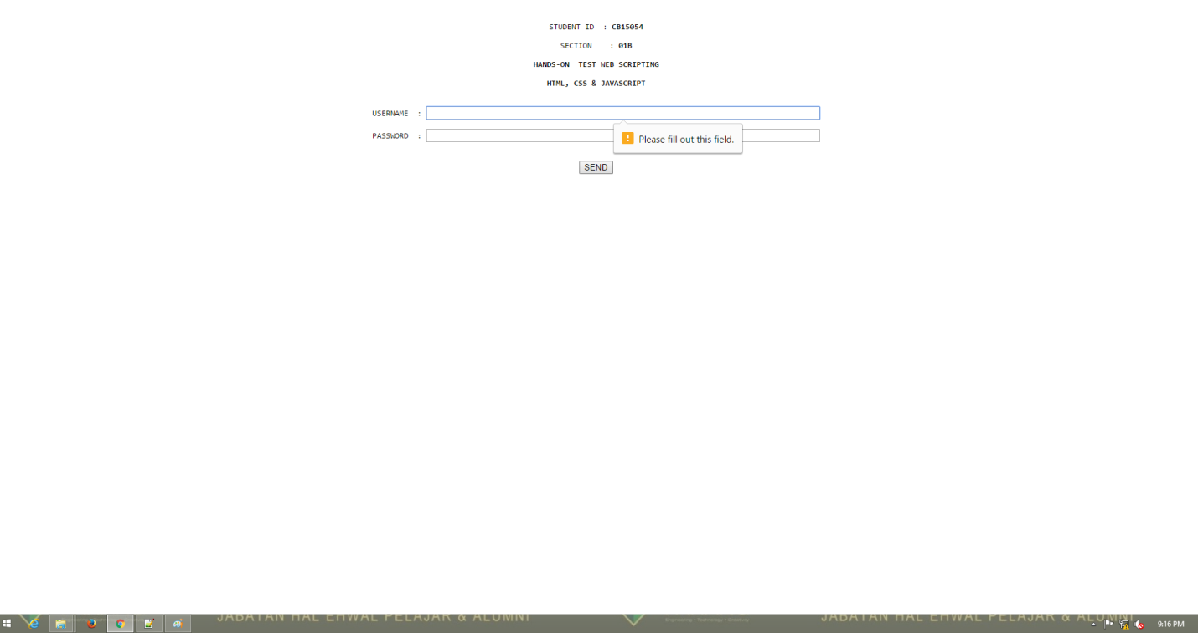

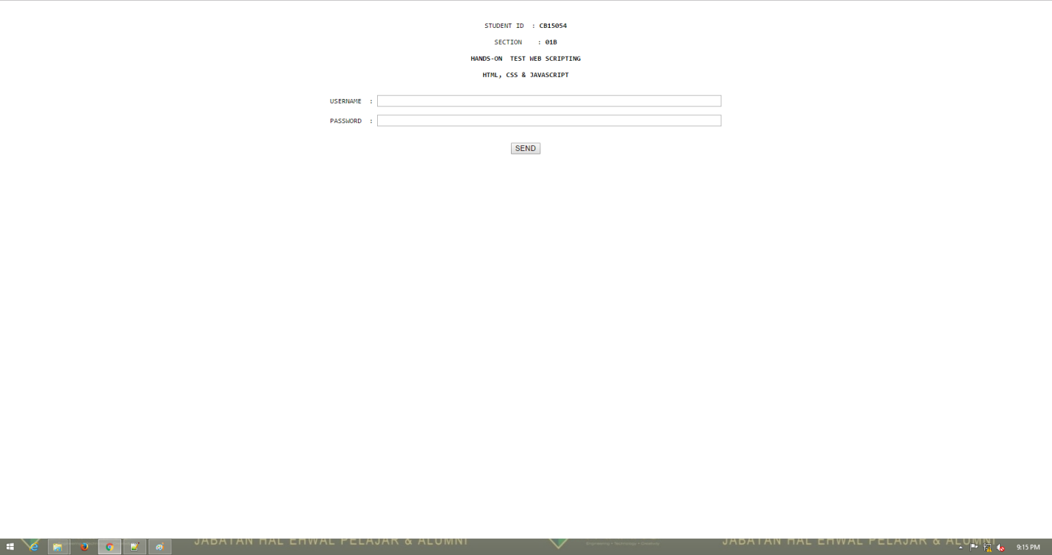

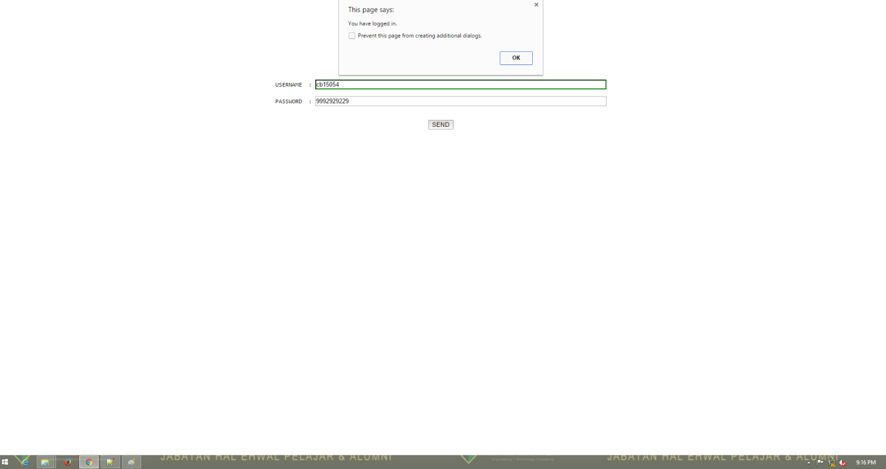

QUESTION 2

<!-- QUESTION 2 -->

<html>

<head>

<title> HOT1_Q2_CB15054</title>

<style type="text/css">

<!--CSS codes-->

</style>

<script type="text/javascript">

// This javascript has been taken from stackoverflow. This code shows how to calculate the total number of characters typed in the textarea.

function countChars(countfrom,displayto) {

var len = document.getElementById(countfrom).value.length;

document.getElementById(displayto).innerHTML = len;

}

</script>

</head>

<body>

<center>

<pre>

STUDENT ID : <b>CB15054</b>

SECTION : <b>01B</b>

<b>HANDS-ON TEST WEB SCRIPTING</b>

<b>HTML, CSS & JAVASCRIPT</b>

Type something here below!

<textarea name="textlalala" id="data" cols="35" rows="15" onkeyup="countChars('data','charcount');" onkeydown="countChars('data','charcount');" onmouseout="countChars('data','charcount');"></textarea>

Total number of characters including whitespace :

<h2><b><span id="charcount">0</span> characters entered. </b></h2> <!-- This will pop out the number of characters typed inside the textarea. This source code is taken from stackoverflow as well. -->

Total number of characters 'A' in the text :

</pre>

</center>

</body>

</html>

SCREENSHOTS

